# 

**Electronic products piano sales company**

**Group: 26**

**Word Count: 3147**

**Group Members:**

|  |  |  |
| --- | --- | --- |
| **Name** | **QM student number** | **BUPT student number** |
| **Zeyang Sun** | **190017686** | **2018212939** |
| **Luo Deng** | **190016656** | **2018212966** |
| **Caitong Tang** | **190016058** | **2018212935** |
| **Liu Jiayun** | **190018568** | **2018213227** |
| **Jia Xinyu** | **190019196** | **2018213107** |
| **Liu Litao** | **190018731** | **2018213155** |
| **Ma Fubo** | **190012898** | **2018212862** |
| **Tang Hongjing** | **190013116** | **2018212601** |
| **Zhang Yijue** | **190015040** | **2018212872** |
| **Zhu Sihang** | **190014294** | **2018212719** |
| **Dai Kunling** | **190013563** | **2018212581** |

Catalog

1. Introduction 1

1.1 Arduino Electronic Organ 1

1.2 Database 1

1.3 Website 2

2. Arduino Electronic Organ 3

2.1General design process 3

2.2 Product Design 4

3. Databas 11

3.1 General design process 11

3.2 Design of Database 12

3.3 GUI interface 14

4. Website 27

4.1 General design process 27

4.2 Login and register 28

4.3 Product display page 28

4.3 Consumer information display and modify 32

4.4 Order 33

5. Video General Idea 37

6. Team division of work 38

6.1 Arduino Electronic Organ 38

6.2 Database 39

6.3 Website 40

7.Meeting and group work 41

7.1 Critical meeting table 41

7.2 Our Working Photos Below 42

# Introduction

## Arduino Electronic Organ

Arduino Electronic Organ is a portable electronic keyboard, which is produced by Nicekey. The product is designed based on Arduino Mega2560 board. Its fundamental components consist of ultrasonic sensors, LCD, infrared remote control, etc.

The product has 7 modes of different functions, which can be switched by a remote control. First and foremost, it has the fundamental function of music playing with LCD prompts, which allows for two playing modes, keystroke playing and ultrasonic playing. Besides, it provides 4 acoustic effect modes, including Tenuto, Tremolo, Arpeggio, and Synthesizer sound. And there is an additional feature auto play as well.

Arduino Electronic Organ adheres a concise design concept, which maximizes the maintainability and portability of the product. The appearance of minimalism and variety of functions are supposed to attract a large amount of music enthusiasts.

## Database

Based on the large data volume, high concurrency and confidentiality requirements of online shopping websites, we design a relational model database with a wide range of applicability and high read and write performance. The N-N relationship for the relationship between the order and the product is designed to describe the entity model, and is also conducive to the operation of the data, improving the ease of use and IO performance of the database. It is worth mentioning that we carry out MD5 encryption processing of users' personal information within the database to further protect the security of user data.

On top of that, we designed a database management system with a graphical interface based on the database. We use simple and easy-to-use JAVA Swing components to build and integrate the GUI components, and provide different management interfaces for different users, including ordinary merchants and administrators, so that they can easily and quickly manage the database under their own authority. The important thing is that the significant operation interface is designed to be dumb-proof, which can effectively prevent the catastrophic consequences caused by user misuse.

## 1.3 Website

We are now in the era of the Internet, which is a good time. Through Internet technology, everyone can enjoy remote services without leaving home. After the rise of mobile payment, express delivery and delivery services have made our shopping experience more convenient than ever.

That’s the reason why we want to make a web page to display our products. Everyone can via our website to learn more about our company cultures. The idea of our web design is to let every user who enters our website quickly find the most suitable electronic organ from our products through the most concise and direct display.

# Arduino Electronic Organ

## 2.1General design process

## 

## 2.2 Product Design

#### 2.2.1 Appearance design

3D printed shell is well-designed with reserved position for electronic screen, Ultrasonic wave interface, USB interface and loudspeaker and keyboards.

Arduino Electronic Organ adheres a concise design concept. 3D-printing shell covered with Matte black protective film and keyboard simulated white buttons, which keeps the classical piano element.

Taking into account the touch of the buttons, the keyboard are computer keyboard buttons.

#### 2.2.2 Hardware design

1. 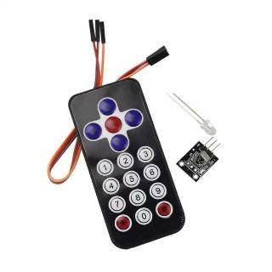Power supply

Connect USB Interface to the source.

1. Infrared Remote control

Press the corresponding button and change the mode whenever you want.

#### Function design

1. Basic function

User can press the key to play. At this time, the eight keys represent the eight notes from C5 to C6.

2. Modes

* Tenuto. Extend the specific note.
* Autoplay. The organ plays the fixed repertoire "Auld lang syne" with instant pitch display on the keyboard screen.
* Tremolo. The tremolo can be played by pressing the button for a long time.
* Ultrasonic. According to the ultrasonic return distance, different sounds can be played. At the same time, the LCD display will display the specific value of the current distance.
* Arpeggio. The first four keys are in C major and the last four keys are in D major.
* Synthesizer sound. Sounds like electronic sound.

#### 2.2.4 Software design

**1. The general structure of the code**

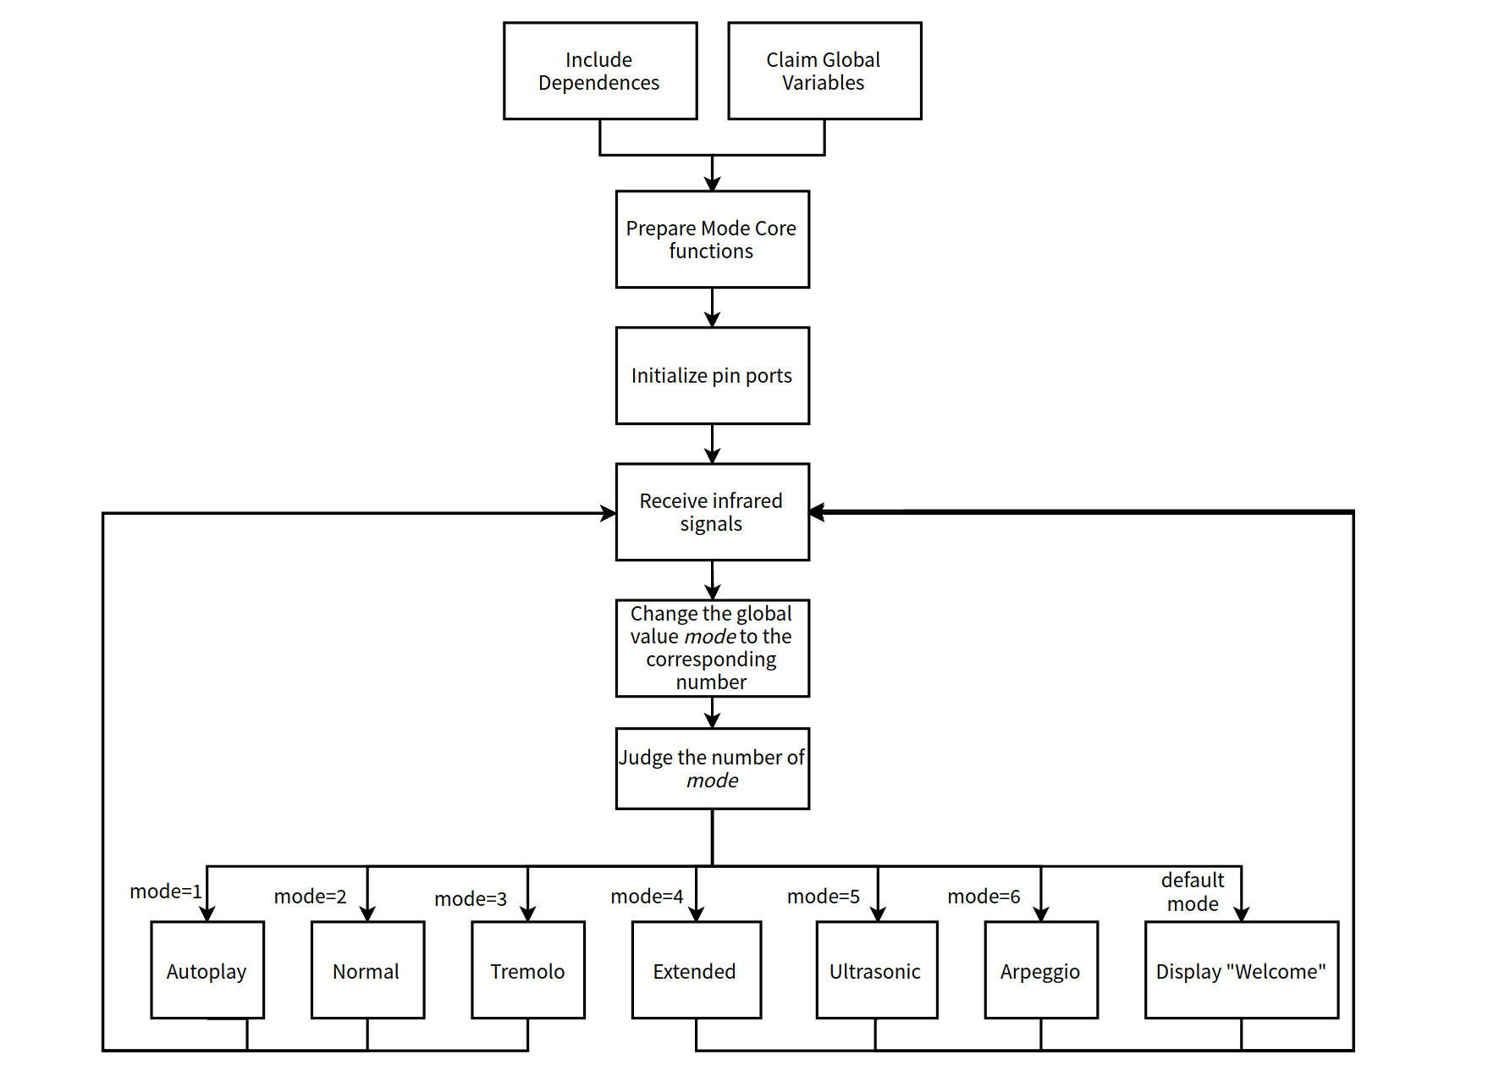

**2. Details about the code**

**Step 1**

Include all dependencies and global variables

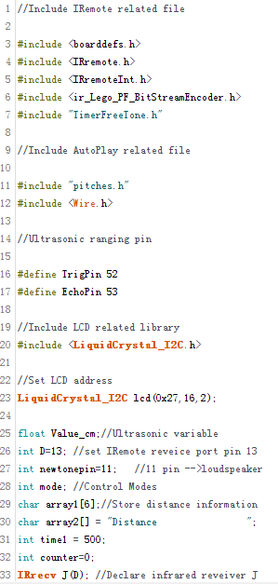

**Step2**

In void setup(), set the pin port.

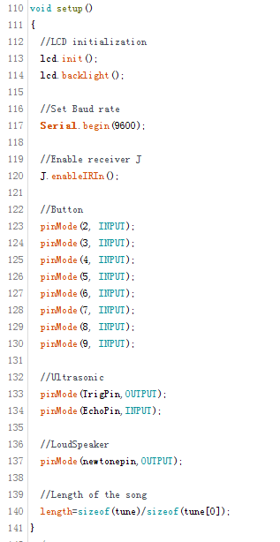

**Step3**

Structural design---Function of each mode

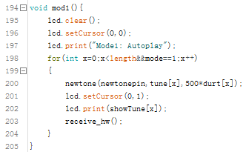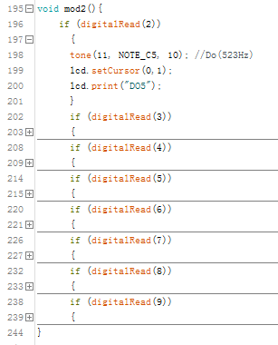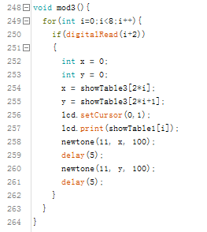

**Step4**

Structural design---Function of infrared remote mechanism

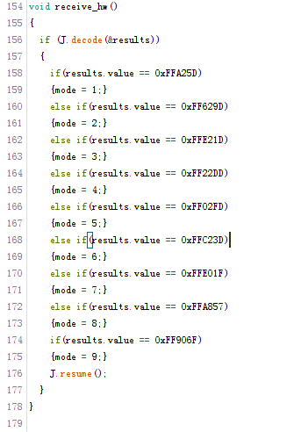

**Step5**

In void loop(),the Arduino starts to run the main part of the code

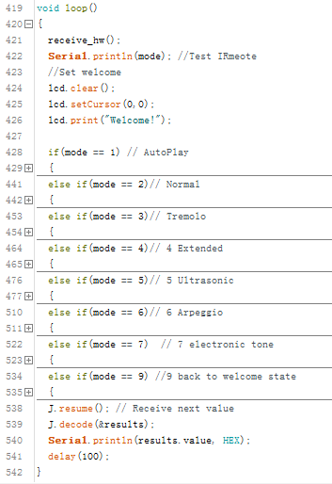

# 3. Database

## 3.1 General design process

## 3.2 Design of Database

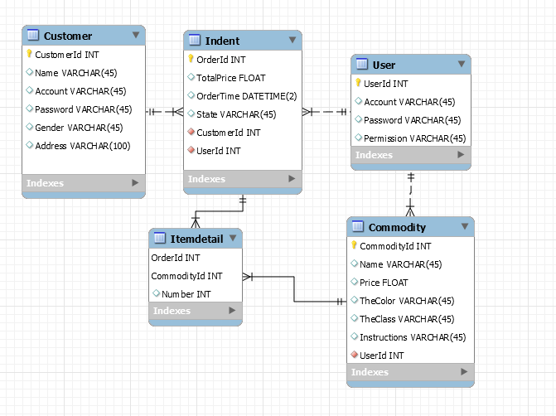

The name of our database is' managementsystem '

Our database needs to contain customers, merchants, administrators, orders, commodities and other information. Therefore, in order to ensure that our database is complete and not redundant, we have created five tables: Commodity, Customer, Indent, ItemDetail and User.

In table 'Customer' : We created a 'CustomerId' for int data type as the primary key of 'Customer', we created attributes such as' Name, Account, Password, Gender, Address ', and set the data type of attributes other than Address to VARCHAR(45), and set the data type of 'Address' to VARCHAR(100) to meet the requirement of Address length.

In table 'user' : We created a 'UserId' for the int data type as the primary key for 'user', we created the 'Account, Password, Permission' properties, and set the data type of these properties to VARCHAR(45). 'User' includes merchants and administrators, who are distinguished by the value of the property 'Permission'.

In table 'Commodity' : We created a 'CommodityId' of int data type as the primary key of 'commodity', we created attributes such as' Name, TheColor, TheClass, Instructions', and set the data type of these attributes to VARCHAR(45). We also create a 'Price' property of data type FLOAT. We set the primary key 'UserId' in 'user' to the foreign key of Table 'commodity'. There is a one-to-many relationship between a business and its merchandise (a commodity can belong to only one business, and a business can own more than one item). This foreign key enables merchants to realize the basic operations such as adding, deleting, modifying and checking their products.

In table 'indent' : We created an 'OrderId' for int data type as the primary key for 'indent', we created 'TotalPrice' for FLOAT type, 'OrderTime' for DATETIME(2) type, and 'State' for VAERCHAR(45) type to ensure the validity of these attributes. To maintain data consistency, integrity, and control over the data stored in the foreign key table, we set 'CustomerId' and 'UserId' to the foreign keys of Table 'indent'. There is a relationship between orders and customers, between orders and businesses, between customers and orders is a one-to-many relationship, between businesses and orders is also a one-to-many relationship. Through these two foreign keys, we can enable customers to query their own orders, so that businesses can query their own orders. The status of an order can easily change as the business or customer's operations change.

In table 'itemdetail' : We add this table mainly to solve the many-to-many relationship between 'indent' and 'commodity'. We combine 'OrderId' and 'CommodityId' as the primary key of 'itemdetail'. Create a 'Number' of type int, which is used to record the purchase quantity of a certain item in an order. There is a one-to-many relationship between 'indent' and 'itemdetail', while there is a one-to-many relationship between 'commodity' and 'itemdetail'. From the perspective of customers, merchants and administrators, this' itemdetail 'shows the number of items purchased in each order and the quantity of each item reasonably.

For convenience and convenience, we set the primary key of 'Customer', 'user', 'indent' and 'commodity' to auto-increment. Thus, when adding records through non-system, we don't need to specify this field, and we don't need to worry about the duplicate of the primary key.

## 3.3 GUI interface

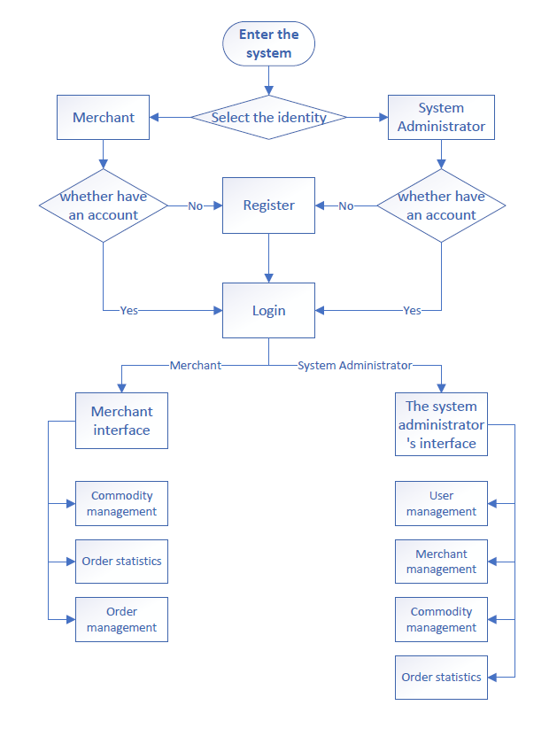

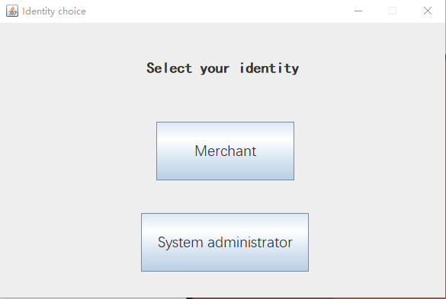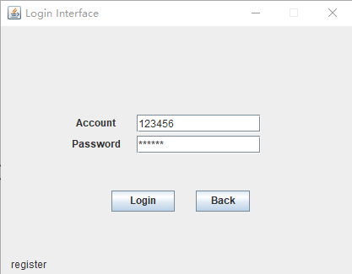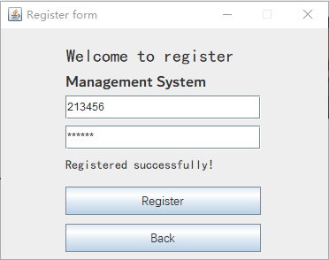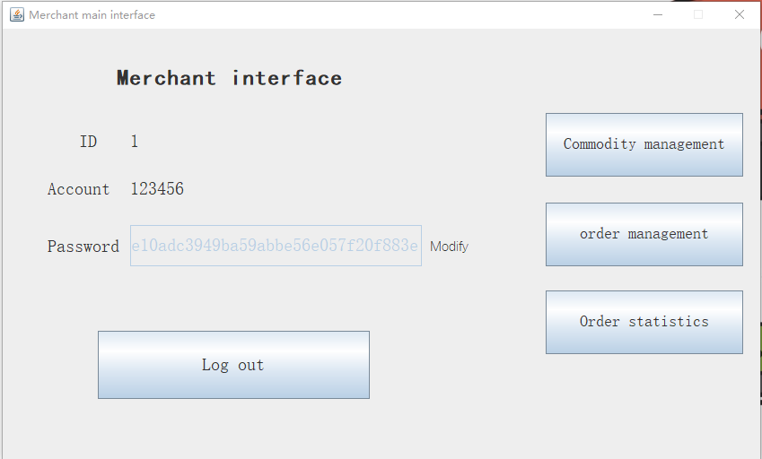

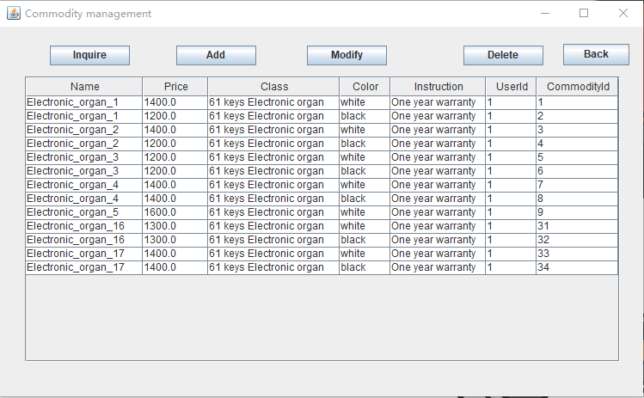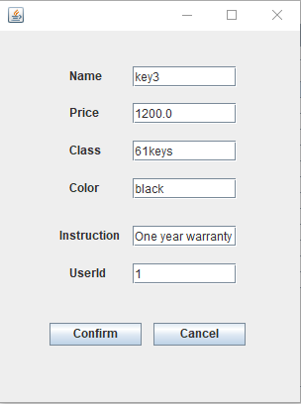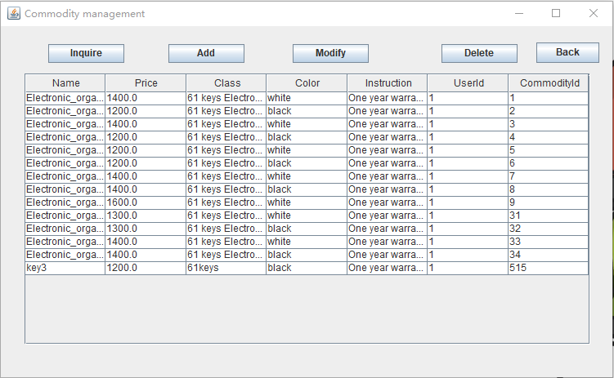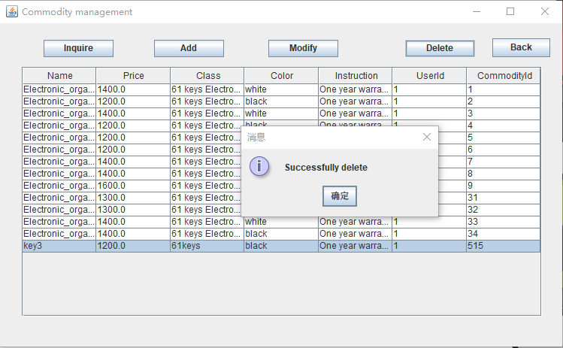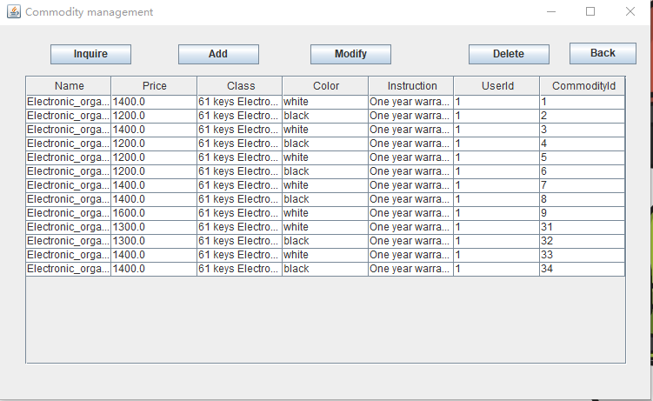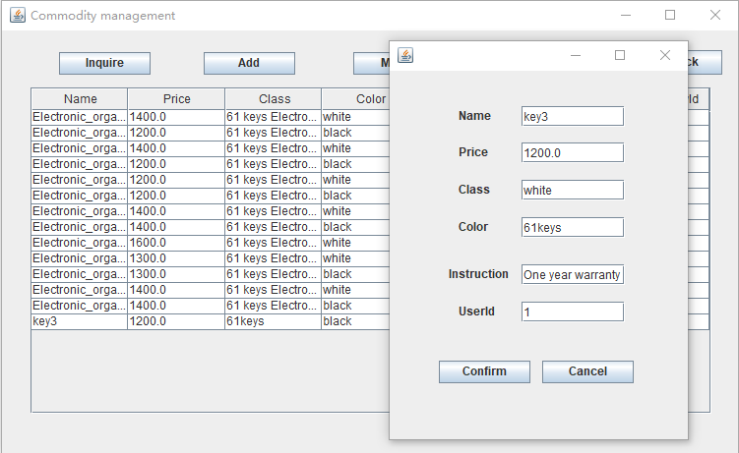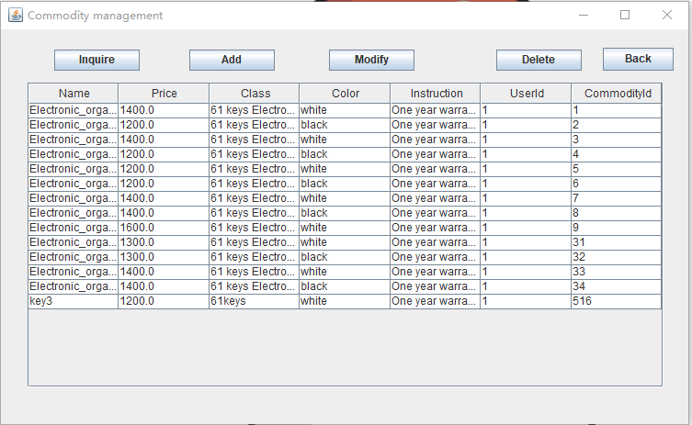

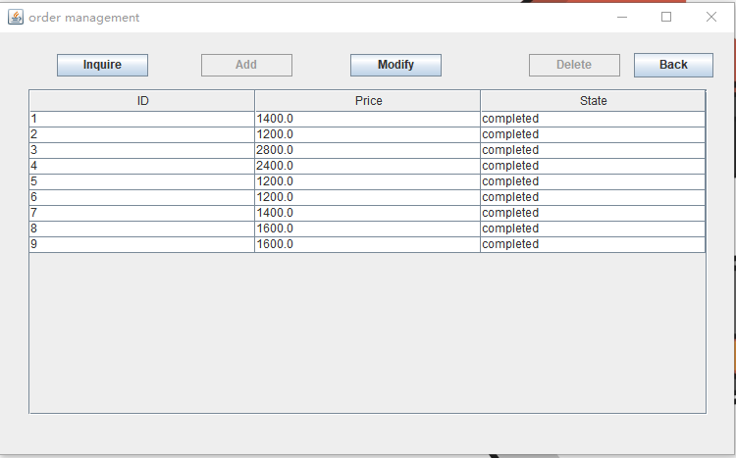

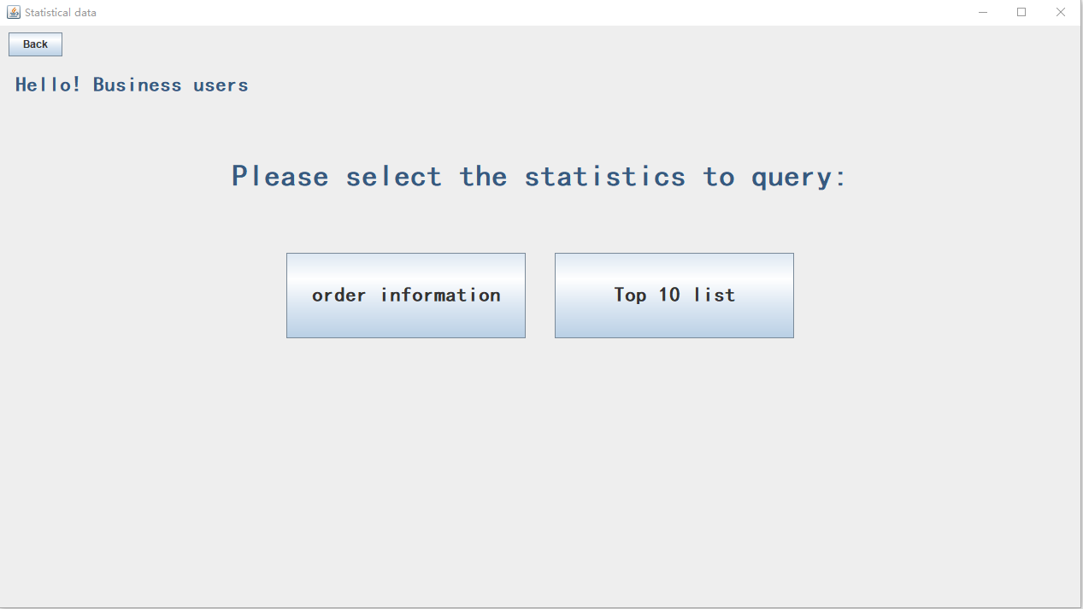

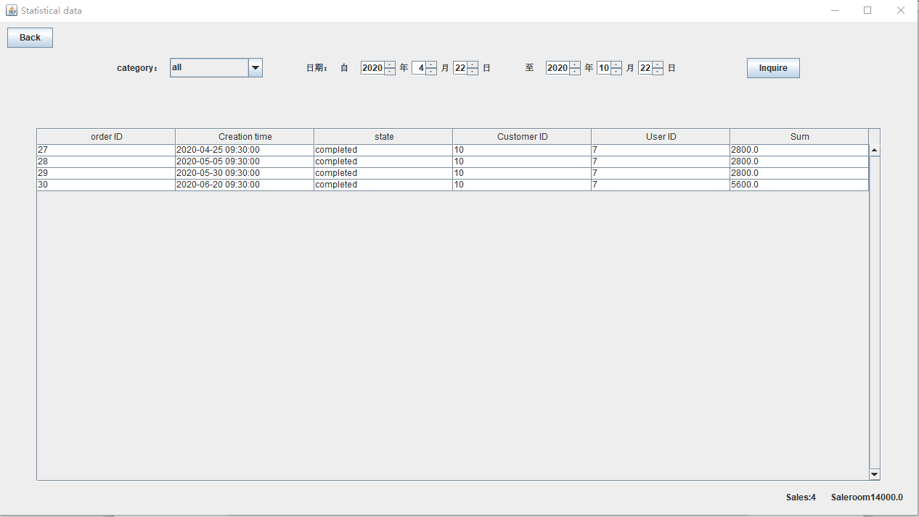

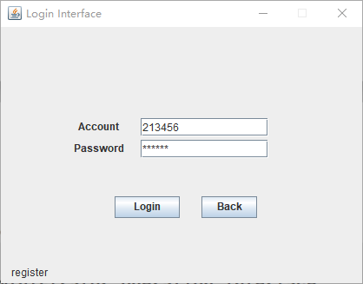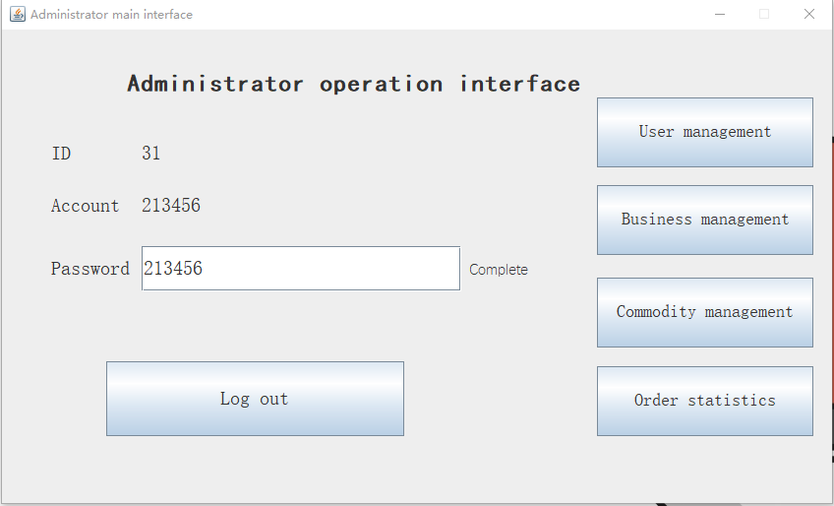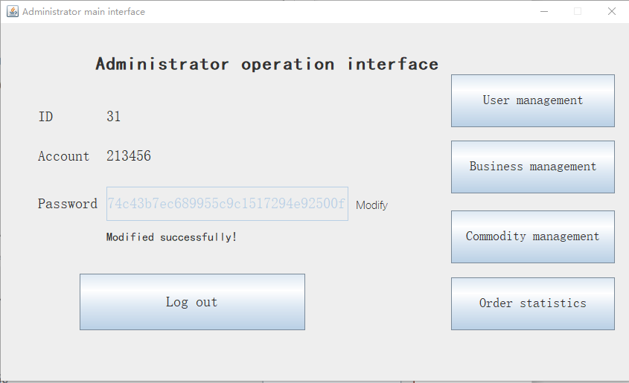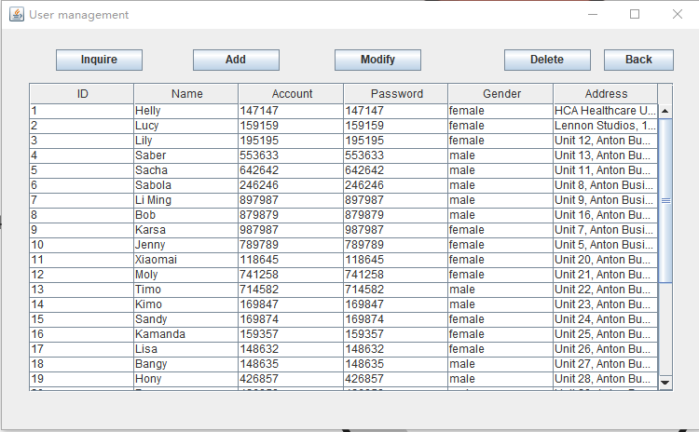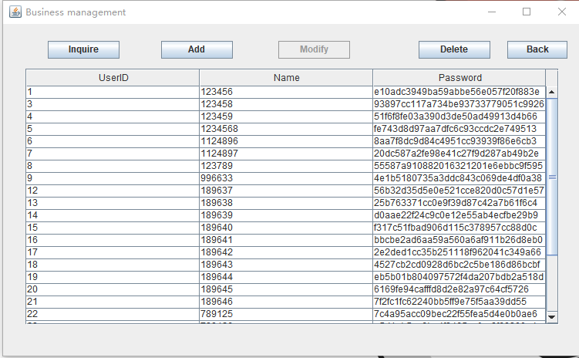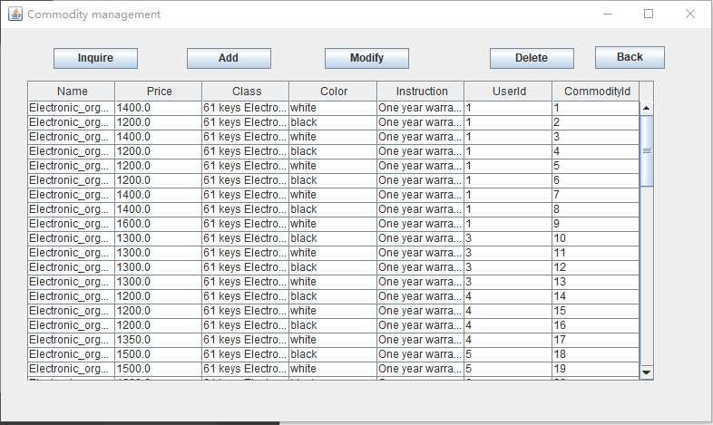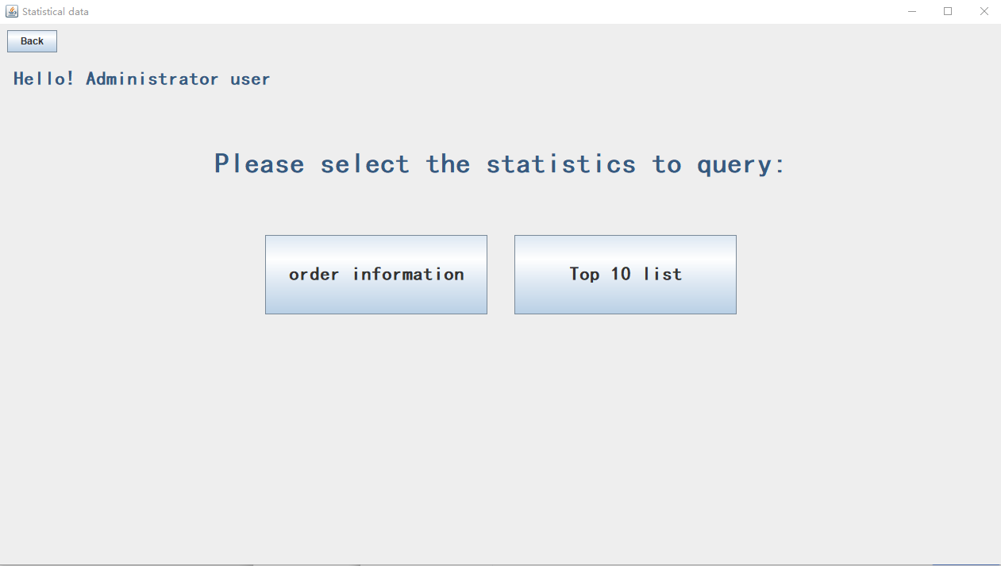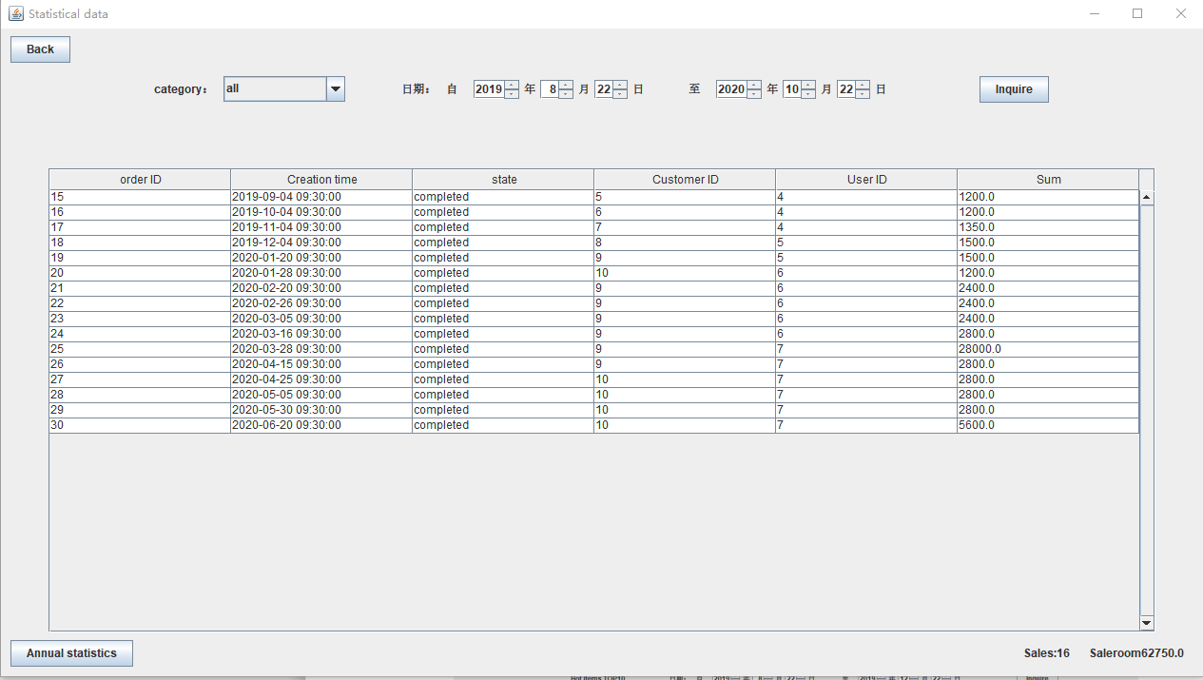 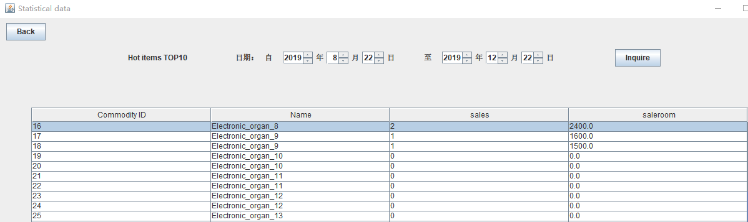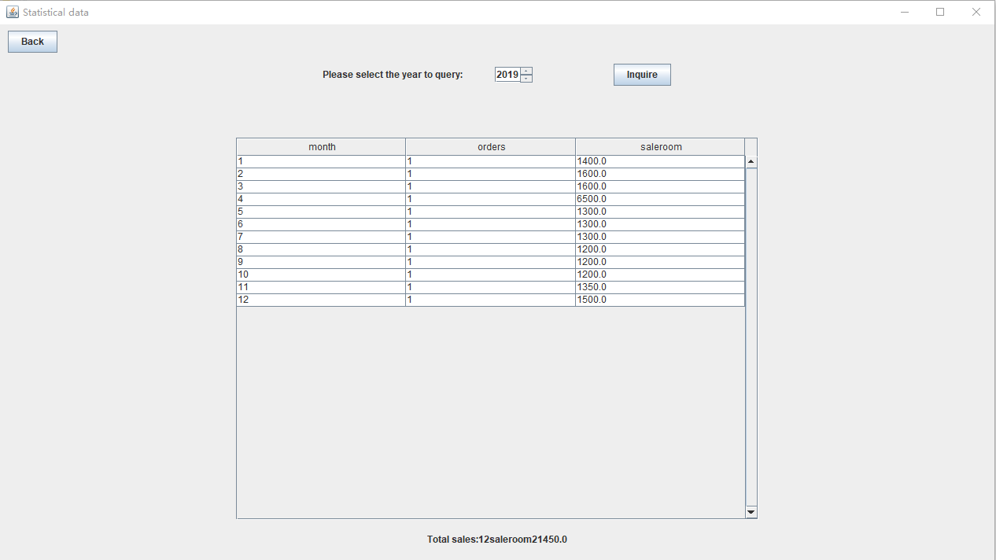

# 4. Website

## 4.1 General design process

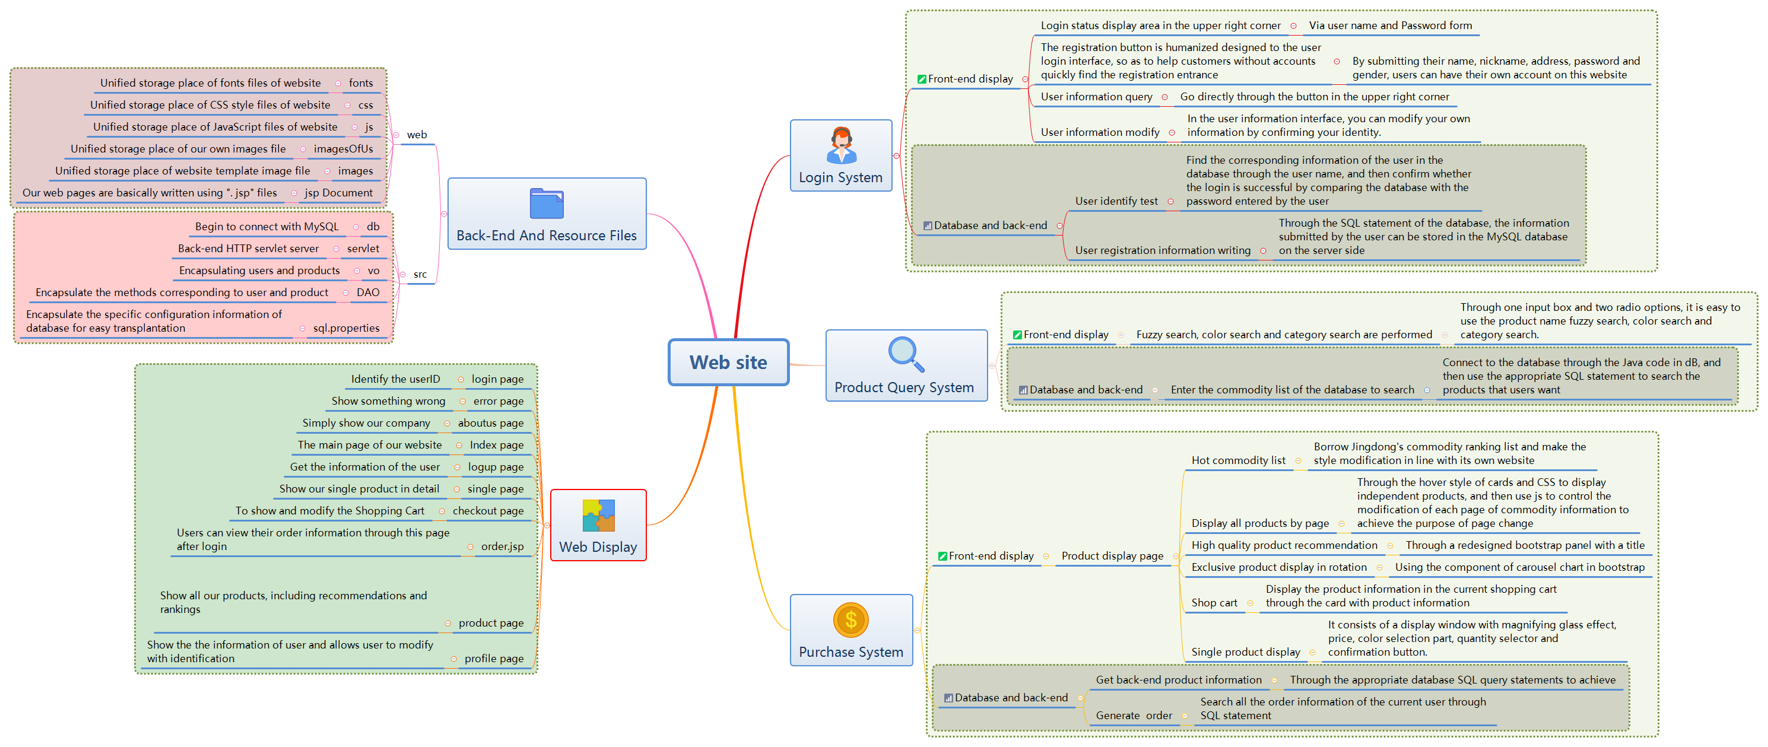

## 4.2 Login and register

Our login registration system is very easy to use. In order to protect the legitimate rights and interests of users, users can only continue to use the unified user agreement when registering a new account. If you have an account, you can easily log in to your account through your account name and user name, so as to prepare for personal operation later.

If you don't log in to your account, you can preview the product, but that's all. You will not be able to generate your own orders and purchase our products.

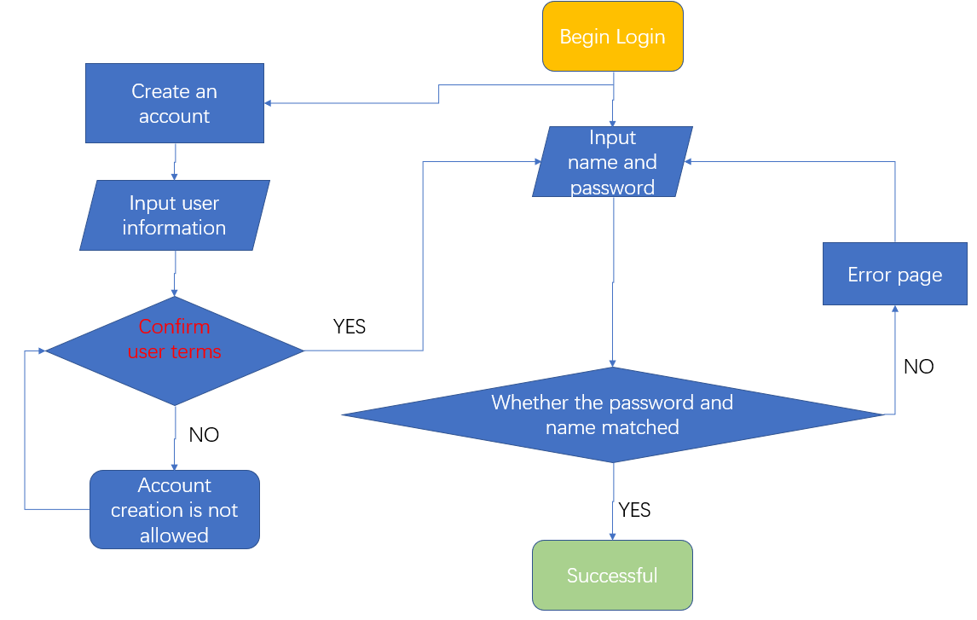

## 4.3 Product display page

#### 4.3.1 Display

Our products display page consisted of five section.

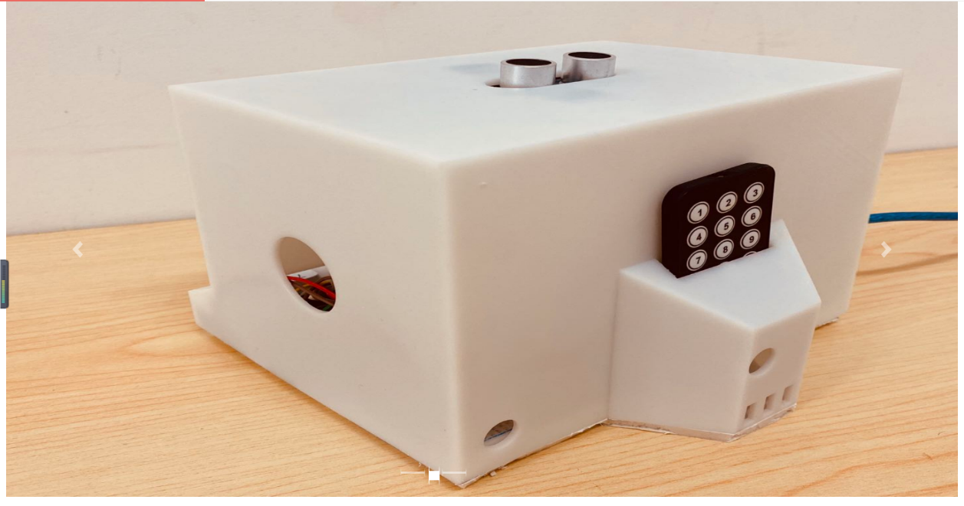**The first part** is a carousel display page, where our best products will cycle through their own photos from all angles.

**The second part**, which occupies the entire column on the far right, is our sales list. In this list, we will dynamically display the top 9 most popular items of each month. See if your favorite products have been put on this list.

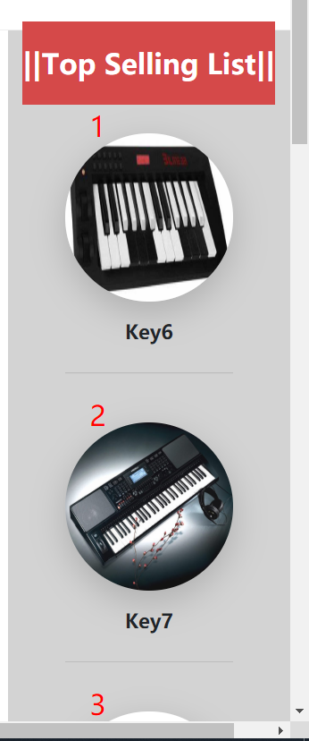

**The third part** is just below the carousel map, where three items recommended by the store manager are put in the most conspicuous place. If you are still hesitant to buy which product, try the product recommended by the store manager.

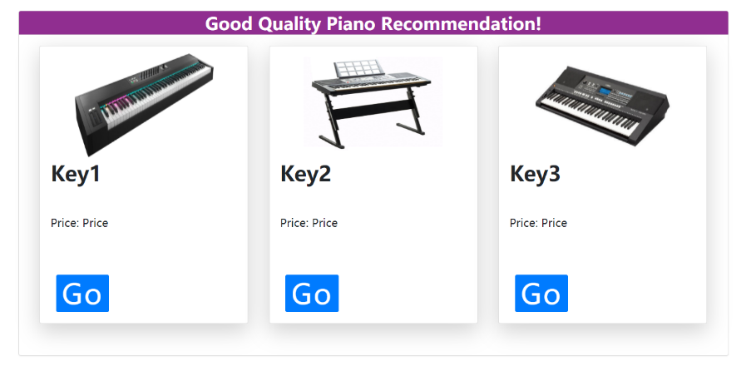

**The fourth part** is the display of all the products. We divided all the products into five pages. Each page can display six different products at a time.

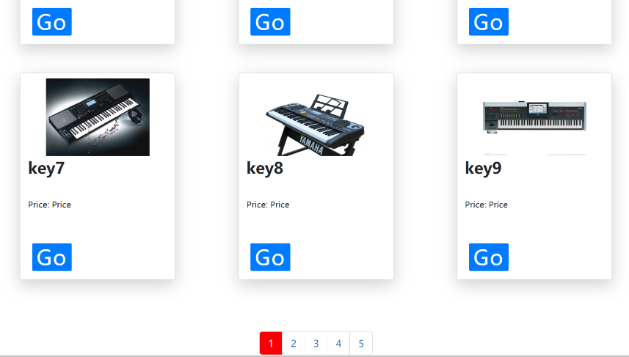

**The last part** is the commodity inquiry system. Here you can easily find the product you want by the name, color or type of the product.

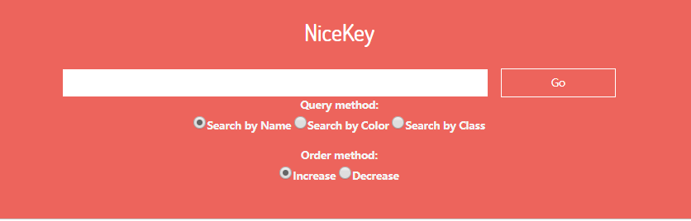

#### 4.3.2 Go Shopping

Go shopping is the process where customers select products exhibited on our website according to their preferences, add to the shopping cart and finally place the orders for different sellers.

The shopping system combines front end and back end tightly, and the flow path of it is listed below. 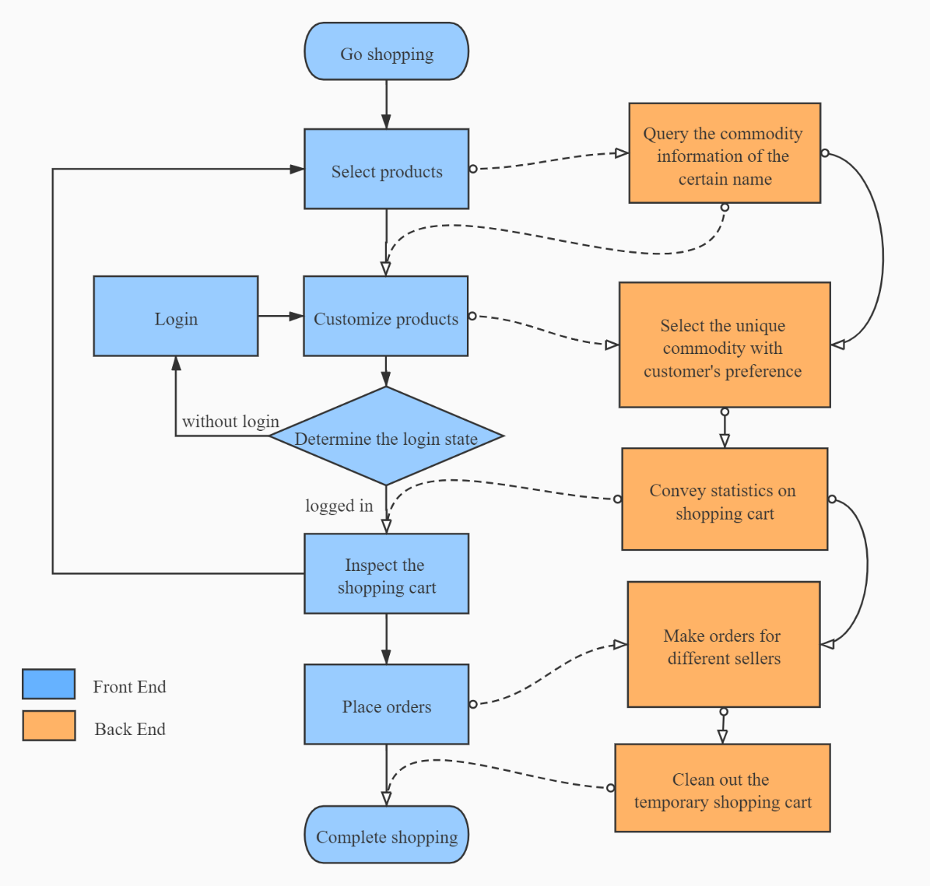

First, when customers decide the products on the display page and click the ***Go*** button of it, the website will skip to the display page especially for concrete information display for single product. The information display is dynamically generated by the user choices on the product, achieved by query product’s name in the database.

（放一张single.jsp展示图）

In this page, customers will view the appearance and features for this product, and can make customizations for the product, such as the purchase amount, the color, etc. Because some versions of certain color are limited, these versions are set on higher prices, and the price label will automatically change in dependency on the changes of the color selection.

（放两张页面图，一张是选了白色，另一张选了黑色）

After customers finish their deciding and click the ***Add to Cart*** button, website will check the login state of them. If customers haven’t login, the add will be cancelled and website will skip to the login page. Else, customers can normally add their products.

（放一张未登陆状态的图，和一张跳转到登陆界面的图）

The choices will be stored in the virtual shopping cart, and the website will skip to the checkout page for customers’ inspection of the cart. The data of choices, like amount and color, are transported by website servlet in the back end. The total price and amount of all the commodities are also calculated and displayed on the page.

（放checkout页面图）

Customers now can place the order, or return to the product display page to look for what else they want. Commodities in the shopping cart will be saved and renewed and re-calculated when customers add new products.

（放选择别的商品，然后跳到购物车的页面，两张图）

When customers click ***Place Order*** button, a popup window will be displayed, informing them of completion of orders. Then the website will skip to the index page automatically, in convenience of continuing to shop.

In the back end, the commodities in the shopping cart will be packaged into orders according to the sellers, and input the records into database. The shopping cart will be also cleaned out, preventing mix of new commodities and old ones.

（放一张提醒图，放数据库记录的两张图来对比更新）

## 4.3 Consumer information display and modify

The profile page is definitely important, for it provides users with access to reviewing and changing their personal information.

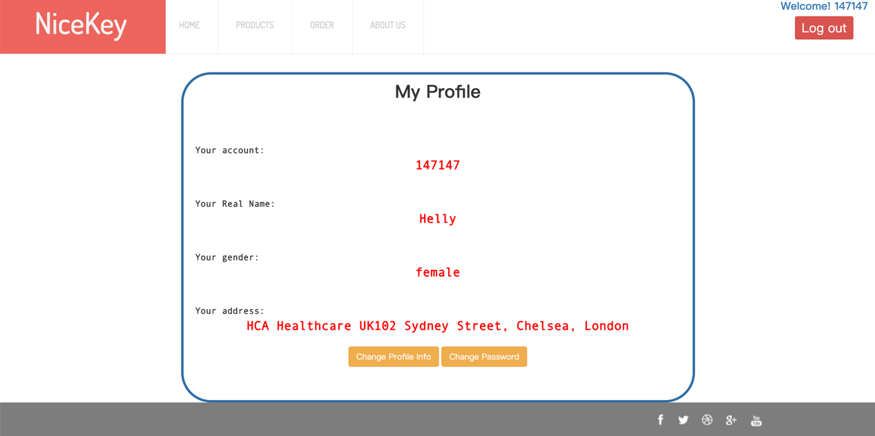

Highlighted in red bold font, information could be clearly read. Two eye-catching buttons provide functions of changing info or password.

A verification would take place for security purpose when you try to change your information. Click into “Change Profile Info”, the window first prompt the user to enter the password to verify.

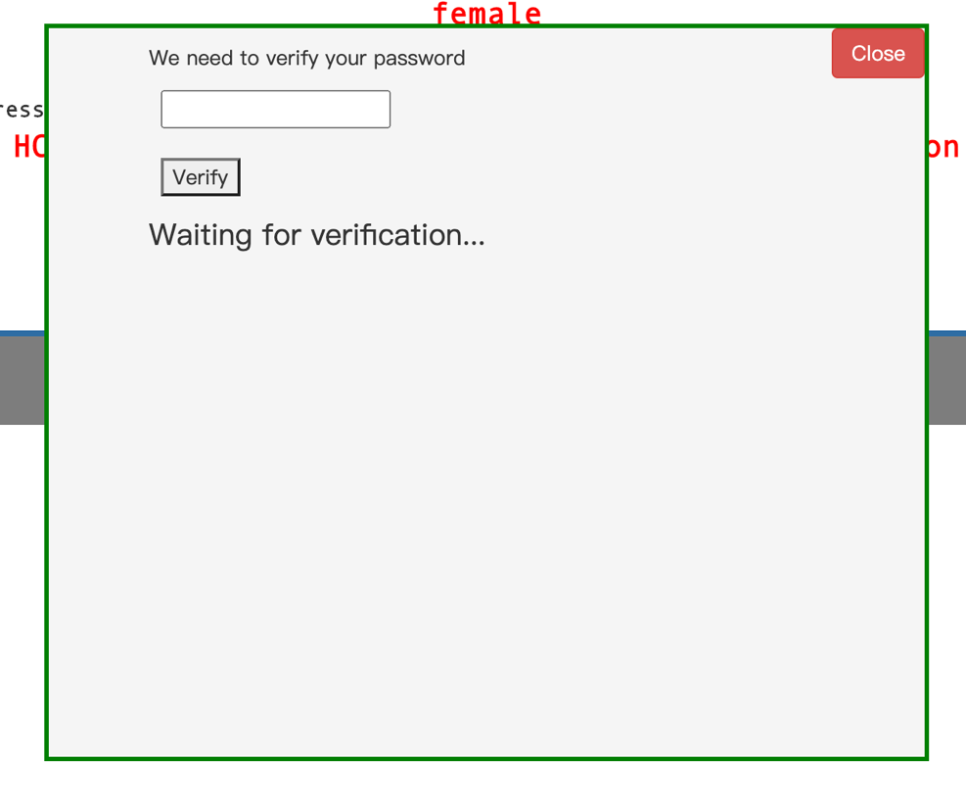

When verification is done, two input box would pop up. Fill in the blanks and click, then the change is done.

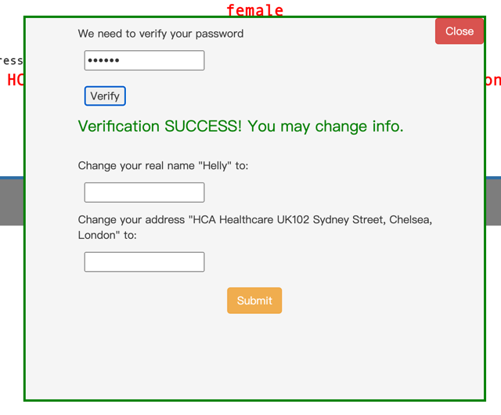

## 4.4 Order

#### 4.4.1 Order display

The Order page is where users can review their orders in detail, including Order ID, products information, current status total price, order time and so forth. Neatly as the information is presented, there are a couple of great mechanisms behind the page presentation.

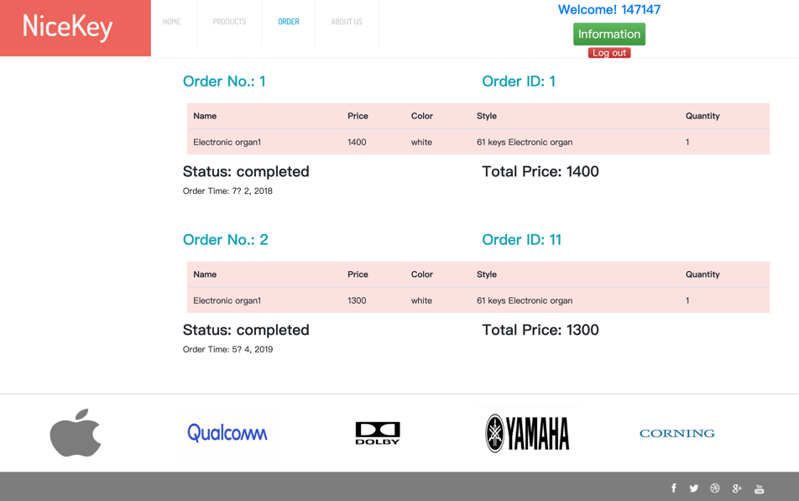

First of all, we thought of an elegant and efficient way to present the orders, which is to use “Vue.js”. As a progressive Javascript framework, vue has brought front-end development great convenience. A simple declaration of variables and iterations helps you build a neat and cohesive presentation.

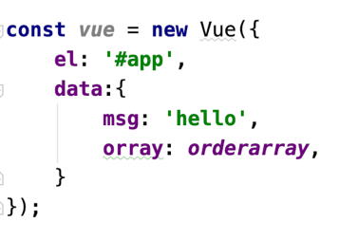

So now comes another problem, which is to pass the arraylist to Javascript (arraylist in Java cannot be directly retrieved by Javascript, which are two different languages. So finally JSON (Javascript Object Notation) comes to our help.

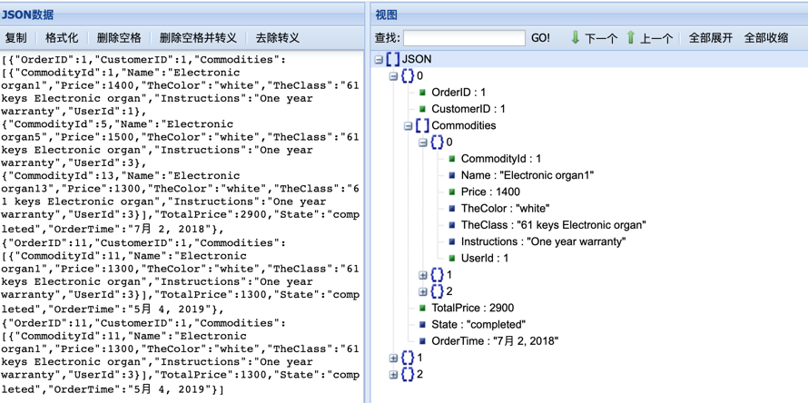

By using the JSON string as a media, the information can be appropriately passed to Javascript, which can be further presented on the webpage.

#### 4.4.2 Order back-end

* Implementation of database interface：

The following is a schematic diagram of the order query process

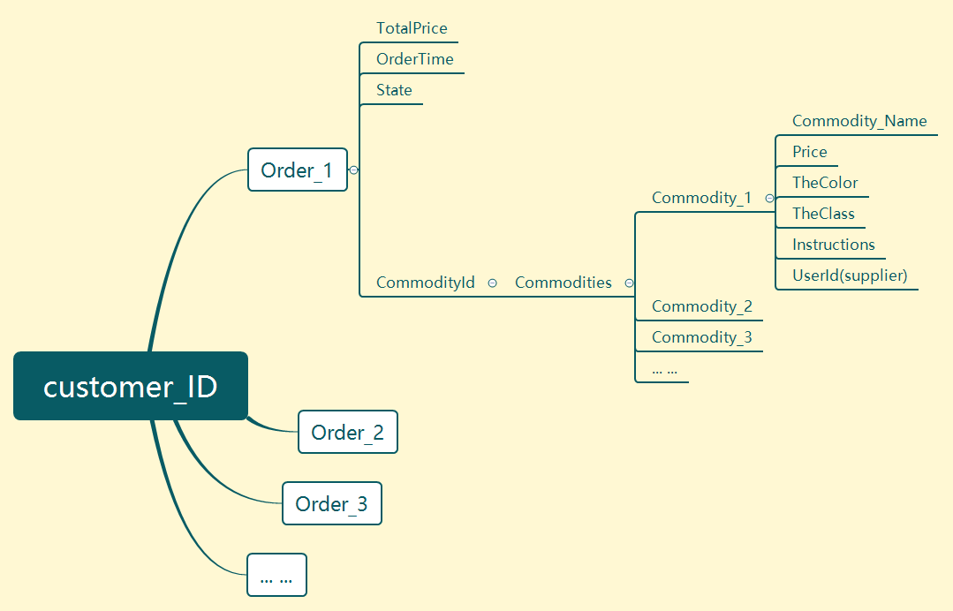

On the realization of order query, we can get all the order data of the user through three nested SQL queries. This data includes the total amount of the order, the generation date, the status, and all the data of all the items in the order.

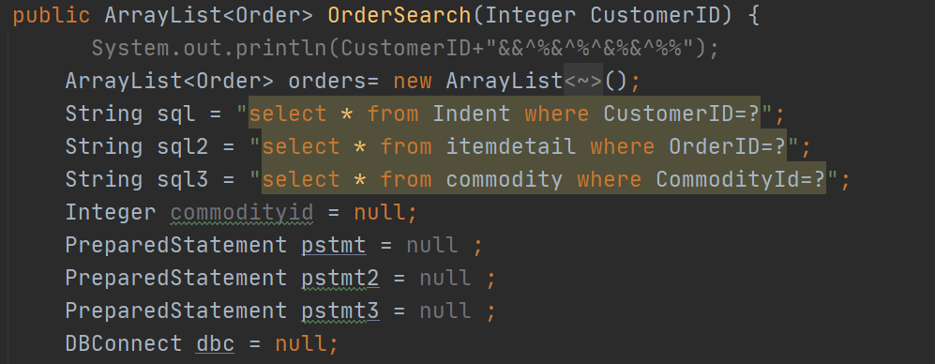**1.**The first cycle gets the basic information of all its orders through the user ID

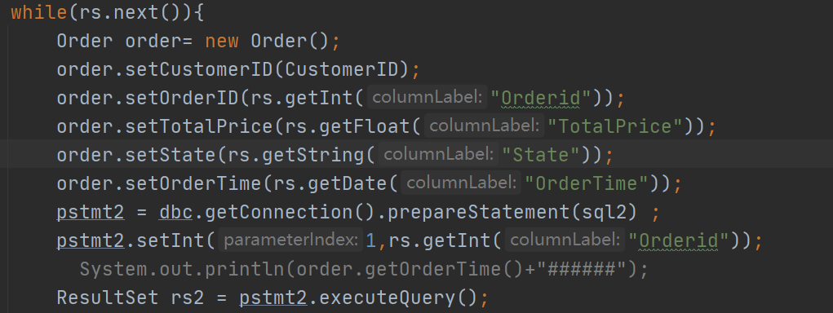

**2.**The second cycle gets the ID of all commodities through the ID of one of the order

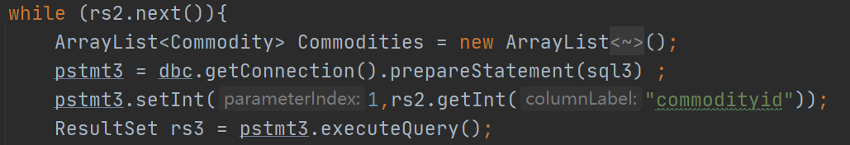

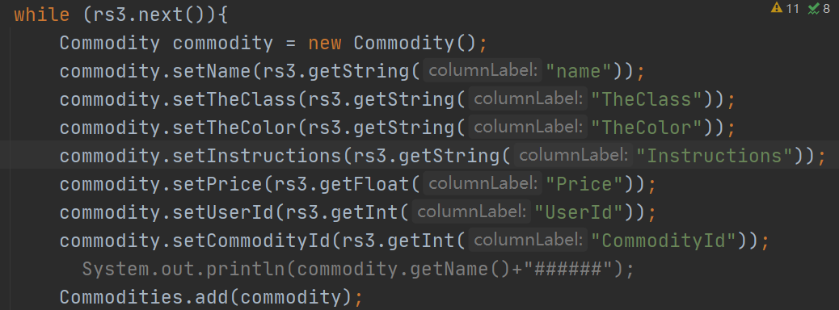**3.**The third loop gets all the attributes of each item in turn by its ID.

# 5. Video General Idea

The main design style of our electronic organ is simple, practical and convenient. At the beginning of the design, each component has its necessary function. This electronic organ has seven functions, through the infrared remote control to switch functions. The infrared remote is to be used with the electric organ, so the electric organ has a space to accommodate the remote. In consider of the variety of taste in appearance, we offered two color schemes.

In order to make the video better, we used the pan-and-tilt camera to shoot the promo, in the post-editing, we use professional special effects technology to show the product highlights. In addition, the voice-over also uses professional recording equipment. Finally our video has a high-end commercial style and dynamic rhythm.

# 6. Team division of work

## 6.1 Arduino Electronic Organ

|  |  |
| --- | --- |
| **Name** | **Work** |
| **Dai Kunling** | **AutoPlay, Infrared control, LCD Display, Ultrasonic, Circuit & welding** |
| **Ma Fubo** | **Appearance Design(3D modeling), loudspeaker, Video shooting** |
| **Zhu Sihang** | **Extended mode, arpeggio, tremolo, Packaging** |
| **Tang Hongjing** | **Infrared control, Powerpoint making, Art words** |
| **Zhang Yijue** | **Implement Basic Normal Function, Infrared control** |

## 6.2 Database

|  |  |
| --- | --- |
| **Name** | **Work** |
| **JiaYun Liu** | **Build the database and write the data, the registration and login interfaces and functions for administrators and merchants, the main interface and functions for administrators and merchants, and the final front-end and back-end integration.** |
| **Litao Liu** | **Designed and coded the order statistics management interface, screened orders under different conditions, annual billing statistics and TOP 10 lists based on various data in both administrators and merchants, and designed the graphical interface.** |
| **Xinyu Jia** | **Design and write the business and system administrator's interface code, including order management, user management, business management and other interfaces, as well as the implementation of these interfaces to increase, delete, modify query functions.** |

## 6.3 Website

|  |  |
| --- | --- |
| **Name** | **Work** |
| **Zeyang Sun** | **Responsible for the selection of the entire site template. The front end of product display page, product search, landing page, registration page and landing status display area are designed. The implementation of the back-end interface of login, commodity search, registration and database connection are completed.**  **Responsible for the division of labor arrangement of the whole team, coordinating the work connection between the database and the website, organizing the group meeting, and completing the main typesetting work of the report.** |
| **Luo Deng** | **Responsible for almost whole back-end data process, the logic of page skipping and some parts of front-end webpage design in website shopping. The shopping process includes selecting commodities, querying and viewing commodity information from our database, customizing the products (choosing color, amount, etc.), determining the login status of customers, inspecting the shopping cart, altering the amount of each commodity in the shopping cart, place orders for different sellers into database.** |
| **Caitong Tang** | **In the e-commerce team, he mainly focuses on front end development including webpage presentation design, UI modification, data integrating and is also involved in a portion of back-end development.** |

# 7.Meeting and group work

## 7.1 Critical meeting table

|  |  |  |
| --- | --- | --- |
| **Time** | **Location** | **Procedure** |
| **9.7** | **Classroom N308** | **1. Brief self-introduction.**  **2. Discussed the product blueprint.**  **3. Discussed the learning material sources and clarify tasks of each member.** |
| **9.9** | **Classroom N308** | **1. Check each mode functions.**  **2. Discussed how to merge several functions.**  **3. Brainstorming for better appearance ideas.** |
| **10.18** | **Meeting room 417** | **1.Discussed next project schedule**  **2.display the web page and find the problem**  **3.foud some problem in database** |
| **10.21** | **Meeting room 415** | **Discussed our whole project in detail** |

## C:\Users\孙泽阳\AppData\Local\Temp\WeChat Files\7214997895d4d1128b17241c1a6f060.jpg7.2 Our Working Photos Below

